Sameeh Alqatabi

CS-330

03/13/2023

Project Proposal

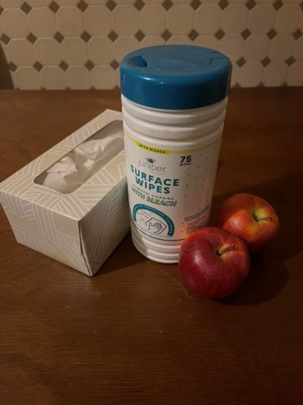

For my 3D scene, I have selected an image of a napkin box, two apples, and a surface wipes on a wooden table. I took this photo myself, which allows me to explore different perspectives of the objects and create a more accurate 3D scene. To create these objects in 3D, I will be using four different primitive shapes: cubes, spheres, cylinders, and planes. The two apples will be made using spheres. The napkin box will be created using a cube, and the surface wipes will be made using a cylinder shape. The wooden table will be created using a plane shape.

I chose these primitive shapes because the spheres are perfect for creating the apples' round shape, and the cylinders will work well for the surface wipes. The cube shape will be perfect for the napkin box, and the plane will serve as a foundation for the entire scene.